Introduction
On the eve of the First World War, Russia's legal hierarchy of estates (clergy, nobility, merchant, peasant) was increasingly at odds with a newer social structure based on occupation and economic function. Intensive industrialization programs beginning in the 1890s stimulated the development of an urban working class, which, like the more numerous peasantry, struggled to overcome chronic impoverishment. The caricature below of Russian society dramatizes the exploitation of the workers and peasants whose labor supported the upper layers of the "cake" of society.

Document
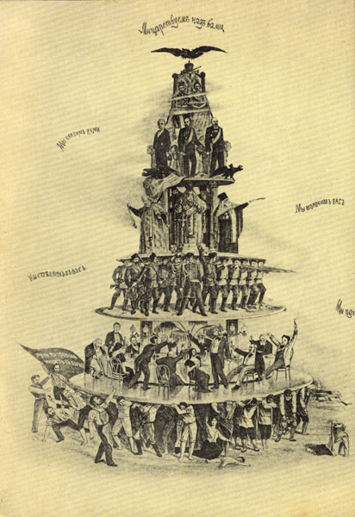
Translation (from top to bottom):
Tsar - "We reign over you;" Ministers - "We rule you;" Clergy - "We fool you;" Gendarmes - "We shoot you;" High Society - "We eat you."

