AP Research
Purpose
The AP Research course allows students to deeply explore an academic topic, problem, issue, or idea of individual interest. In AP Research, students cultivate the skills and discipline necessary to conduct independent research and inquiry in order to produce and defend their scholarly work. Students design, plan, and implement a yearlong investigation to address a research question they have generated, developed and revised. Through this inquiry, they learn research methods, employ ethical research practices, and access, analyze and synthesize information. Students reflect on their skill development, document their processes, and curate the artifacts of their scholarly work through a process and reflection portfolio (PREP). The course culminates in an academic paper of 4,000-5,000 words (accompanied by a performance, exhibit, or product where applicable) and a presentation with an oral defense component.

Materials Needed
-Writing utensils (pencils and black pens)
-Two composition notebooks
-3-ring binder for ONLY AP Research
-Pack of binder dividers (paper or plastic…up to you)
-TBD

Textbooks Provided
Information Now (Upson, Hall and Cannon)
Students’ Guide to Writing College Papers: Fourth Edition (Turabian)

Optional Supplemental Text
The Craft of Research: Fourth Edition (Booth, Colomb, Williams, BIzup, and Fitzgerald)

AP Classroom
We will have the opportunity to utilize AP Classroom, created by CollegeBoard. This online module resources allows teachers to assess student knowledge, progress, and understanding through a variety of online quizzes, assessments, and modules.

Homework Policy
Much of this course is self-paced, so it will be very easy to fall behind. A number of soft deadlines and check-ins will be scheduled by the instructor to ensure student success along the way. Also, occasional readings from the textbooks will be assigned, as well as practice sources. To ensure that in-class activities are as beneficial as possible for all students, it is critical that assigned homework is completed and on-time. Late grades of 50% will be issued if an assignment is completed or turned in late.

Grading Scale
Engagement (homework, discussion, performance tasks, etc): 40%
Tests/Projects/Essays: 35%
Quizzes: 25%

100-90=A 89-80=B 79-70=C 69-60=D 59 and Below=F

AP Research Assessment Overview
Academic Paper (4,000-5,000 words, College Board-scored): 75%
Presentation and Oral Defense (15-20 minute presentation with 3-4 questions from panel): 25%

AP Scholar Participation
Students participating in AP Research are expected to conduct themselves with integrity inside and outside the classroom at all times. They will be held to high academic, behavioral, and attendance expectations. Any student who does not adhere to the attendance or grade requirement (maintaining a 75% or higher) will be at risk for participating in AP Intervention and possibly being exited from the program. Any questions or concerns at any time regarding a student’s participation in AP Research as part of the AP Scholar Academy can reach out to Mr. Kiste.

AP Capstone Policy on Plagiarism and Falsification or Fabrication of Information
Participating teachers shall inform students of the consequences of plagiarism and instruct students to ethically use and acknowledge the ideas and work of others throughout their coursework. The students’ individual voice should be clearly evident, and the ideas of others must be acknowledged, attributed, or cited.

A student who fails to acknowledge the source or author of any and all information or evidence taken from the work of someone else through citation, attribution or reference in the body of the work, or through a bibliographic entry, will receive a score of 0 on that particular component of the AP Research Performance Task.

A student who incorporates falsified or fabricated information (e.g., evidence, data, sources, and/or authors) will receive a score of 0 on that particular component of the AP Research Performance Task.

In keeping with AP Capstone’s policy on plagiarism, AP Capstone teachers and students will use Turnitin to evaluate the originality of student work and ensure that appropriate citations are included. Access to Turnitin is provided to participating AP Capstone schools.

AP Capstone Pedagogical Framework
Students will consider and evaluate multiple points of view to develop their own perspectives on complex issues and topics through inquiry and investigation. The AP Capstone program provides students with a framework that allows them to develop, practice, and hone their critical and creative thinking skills as they make connections between various issues and their own lives. Teachers should help students understand this process is recursive, not linear. The recursive nature of this process allows students to go back and forth between the different stages of inquiry as they encounter new information. (from AP Research Course and Exam Description)

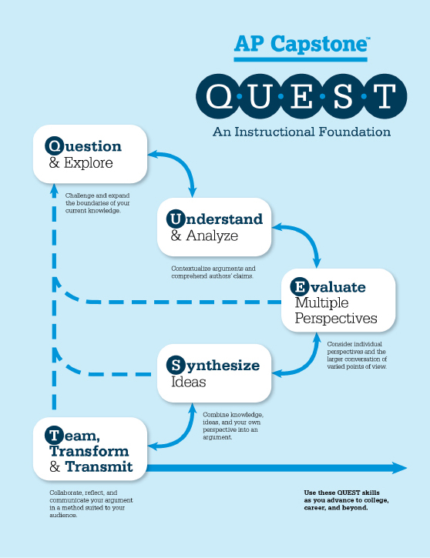

As a student participating on the AP Scholars Academy Capstone course, AP Research, I pledge to:

-Stay organized;

-Conduct myself with integrity inside and outside the classroom;

-Be willing to participate in any and all classroom discussions and activities outside class to prepare for the coursework;

-Utilize ethical research practices;

-Refrain from plagiarism by citing and/or attributing my sources, information, and data;

-Encourage, support, and build up my classmates at all time while providing constructive criticism as needed;

-Maintain a 75% in this and all AP courses, and if I fall behind, to ask for support and assistance.

_______________________________________
Printed Name

_______________________________________
Signature

_______________
Date

