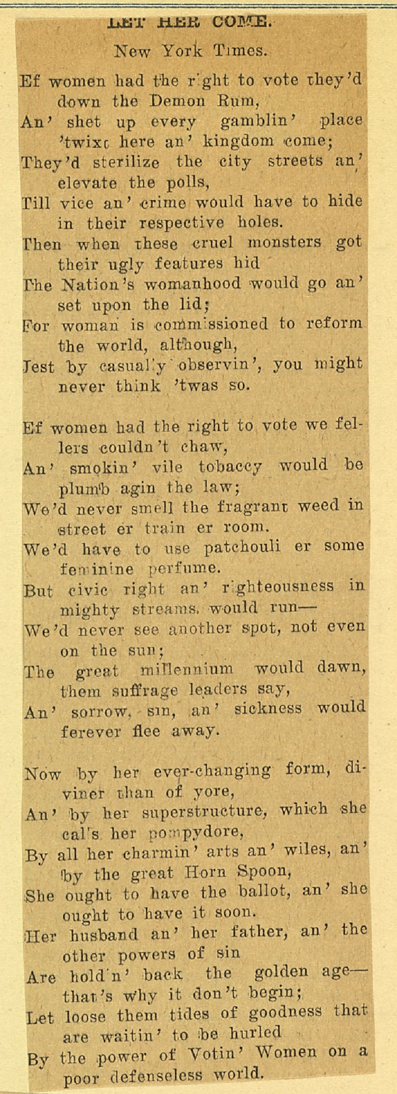
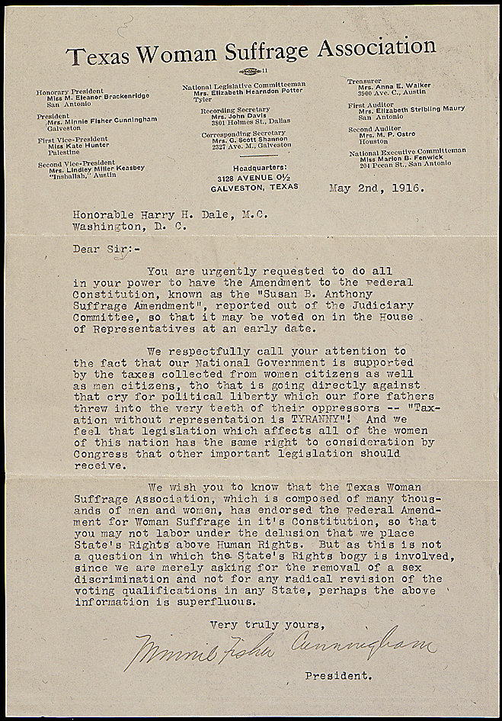

Progressive Argument for Women's Suffrage, 1911
Prepared by H.G. Cattell, Assembly Speaker Pro Tem
 | <-- Go Back | Assembly,  California Legislature  THIRTY-NINTH SESSION  H. G. CATTELL, 67th District  Speaker pro tem  Women should have equal political rights with men as provided for in Senate Constitutional Amendment No. 8 because—  Women are equal to men intellectually. In fact, if we take the number of graduates from our schools and colleges, we must admit that they are farther advanced mentally.  Women should not be subject to taxation without representation any more than men. “Consent of the governed” means women as well as men; for they are subject to government as well as men.  Women are recognized in the family as a large part of the governing force. The state is only a large family composed of both sexes. Why should she not be considered in the government of the larger family?  Women have been given suffrage in numerous countries and in several states in this Union, and partial suffrage in nearly all civilized countries. We have no knowledge of such action having proved to be a failure or of such laws being repealed, which of course, would be done were the experiment not a success.  Women are better morally, as evidence by the criminals in the penitentiaries. For example: in the penitentiaries in California we have about three thousand men and about thirty women, and the cases tried before the police courts probably average about the same. We must, therefore, admit that women would be a great factor in promoting honesty, equity and morality if given the ballot.  It is argued that all women do not wish to vote. The same argument applied to men: for it has become common practice on election days to send conveyances for a large percent of the male voters, and many who go voluntarily do so from a sense of duty. Women, being more faithful to duty, will exercise their right of franchise and do it cheerfully; besides, their presence on such occasions will make the whole occasion more enjoyable as well as a guaranty that everything will be carried on respectably.  Women who are in touch with public affairs are none the less womanly, but, on the contrary, they are better and more companionable wives, more interesting mothers, because they have a common interest with their sons.  The time was thought that to allow a girl a high school education would ruin her morals, destroy her religion, impair her health, make her more masculine, and take away her desire to be a good wife and mother. Such theories are long since exploded, and, as we have progressed in these matters, let us progress in reference to suffrage; let us show the saloon element, the gambling element, the selfish element (for these are the opponents of women’s suffrage) that this great state of California is really a progressive state in every way.  H. G Cattell  Assemblyman in 67th District  Recieved by Secretary of State Frank Jordan on June 24th, 1911, for publication as part of a voters' information manual. Document is currently filed in the California State Archives under: Secretary of State Election Papers, 1911 Special Election

The Woman Suffrage Movement
By Booker T. Washington
I am in favor of every measure that will give to woman, the opportunity to develop to the highest possible extent, her moral, intellectual, and physical nature so that she may make her life as useful to herself and to others as it is possible to make it. I do not, at the present moment, see that this involves the privilege or the duty, as you choose to look upon it, of voting.
The influence of woman is already enormous in this country. She exerts, not merely in the homes, but through the schools and in the press, a powerful and helpful influence upon affairs. It is not clear to me that she would exercise any greater or more beneficent influence upon the world than she now does, if the duty of taking an active part in politics were imposed upon her.
But this is a question concerning which, it seems to me, the women know better than men, and I am willing to leave it to their deliberate judgment. [A]

